How to Use RMH Stocktake

- Open StockTake and log in.
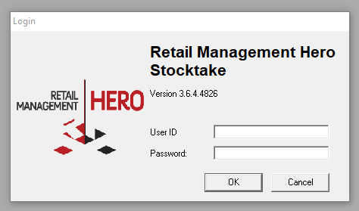
- Click Stocktake.
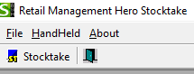
- Click Batch | Create.
- Select your criteria, and then hit Apply.
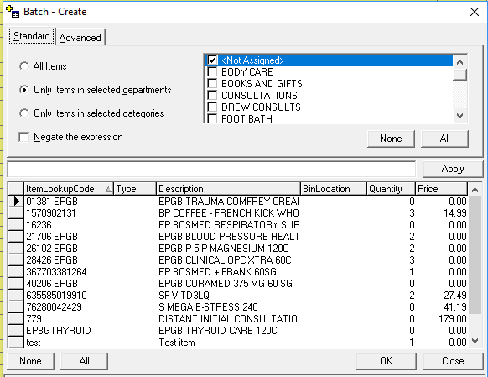
- Select the items you’d like to add (or simply select All), then hit OK, and then Close.
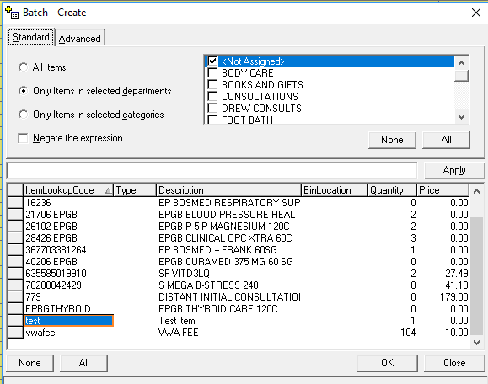
- In this case, I selected Test.
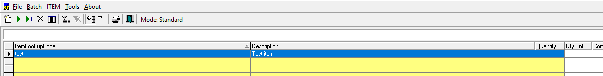
- Now select Batch | Import.
- Click Import, and import the file that you created using the hand held data collector.
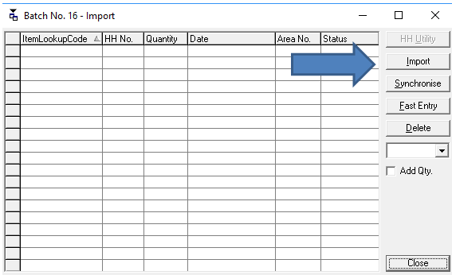
- My file looks like this:
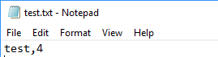
- After importing the file, hit Synchronise (it’s the British spelling), then Close.
- My output looks like this:
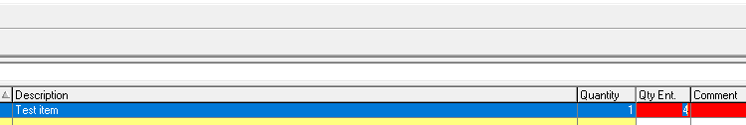
- Note that the current quantity (in RMH Manager) is 1, whilst (keeping with the British theme) the imported quantity is 4.
- Click Batch | Commit.
- Say Yes to the message.
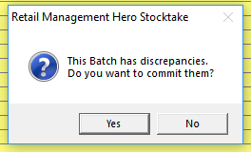
- Now open RMH Manager.
- It’s important to note that items with imported quantities that are GREATER THAN the on hand quantities will be listed in Manager as TRANSFER IN. Items with imported quantities that are LESS THAN the on hand quantities will be listed in Manager as TRANSFER OUT.
- Since, in our example, the imported quantity is greater than the on hand quantity, we need to open TRANSFER IN.
- We will not see the TRANSFER IN until we hit Refresh.
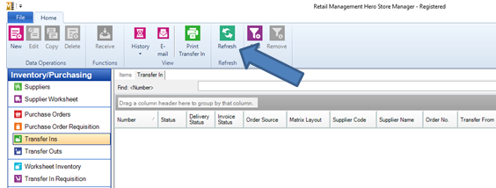
- After Refresh, we get this:
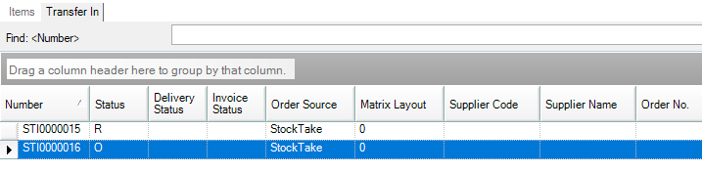
- Process Transfer In order as usual. The inventory will be updated.
IMPORTANT NOTE: Assume that some items exist in more than one location. In this scenario, you have 4 in one location on the shelf, 2 in another location on a different shelf in another location, and 9 in the back room. That’s 3 separate locations. Here’s how you would handle it:
- Complete steps 1 through 8.
- On the same batch, continue to import the other files that contain the items from other locations. You may have imported multiple files into the batch.
- In my case, I have 3 different files, representing an item found in 2 different store locations, as well as the back room.
- When exporting is complete, click Add Qty. before clicking Synchronise. Otherwise, it will simply use the most recent entry, and ignore the others.
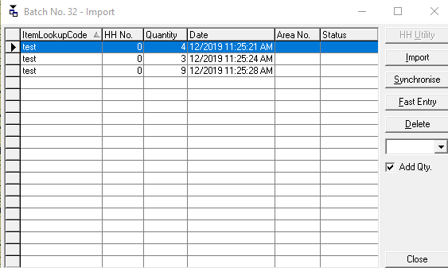
- After Synchronise, click Close. Then filter the results to show only discrepancies by clicking on the grid icon with the minus (-) sign along the top.
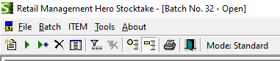
- The result will look like this:
- Repeat steps 13 to 20 to update inventory.
ADDITIONAL NOTES:
- Do NOT import separate batches and update inventory UNLESS you are certain that you are not duplicating items. If, for example, you count 3 of an item, create a Transfer In (or Transfer Out) and Commit it, then later count 4 in another location and do the same thing, your inventory count will read 4 for that item, NOT 7.
- Perform your physical inventory and commit it while the store is closed.
- If you cannot perform inventory while closed, do it on a slow day. Do NOT receive any merchandise into the system during this time. Commit your inventory counts, then run a consolidated sales report showing how many of each item you sold during that day. Then check your inventory for those sold items, making any corrections deemed necessary.
- If you want a report on change in inventory value, click on Batch | Print. You’ll see this:
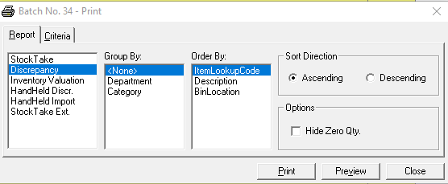
- Click Discrepancy, and Group and/or order by whatever fields you prefer. Make sure you change the printer selection or printer settings if the output looks off.
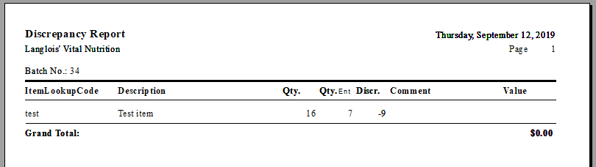
- Before printing, you can also filter your results by clicking on the Criteria tab.
