Advanced Liquor Import Instructions
Use these instructions to put all state sale items on sale in the POS system, update your shelf prices, and print new price labels.
Follow the Basic import instructions and before you click on Import Prices on step 4 follow these instructions.
Step 1: Left click Inv. Class, Left Click Sort, Left Click Ascending. This will sort the items by Inventory Class.
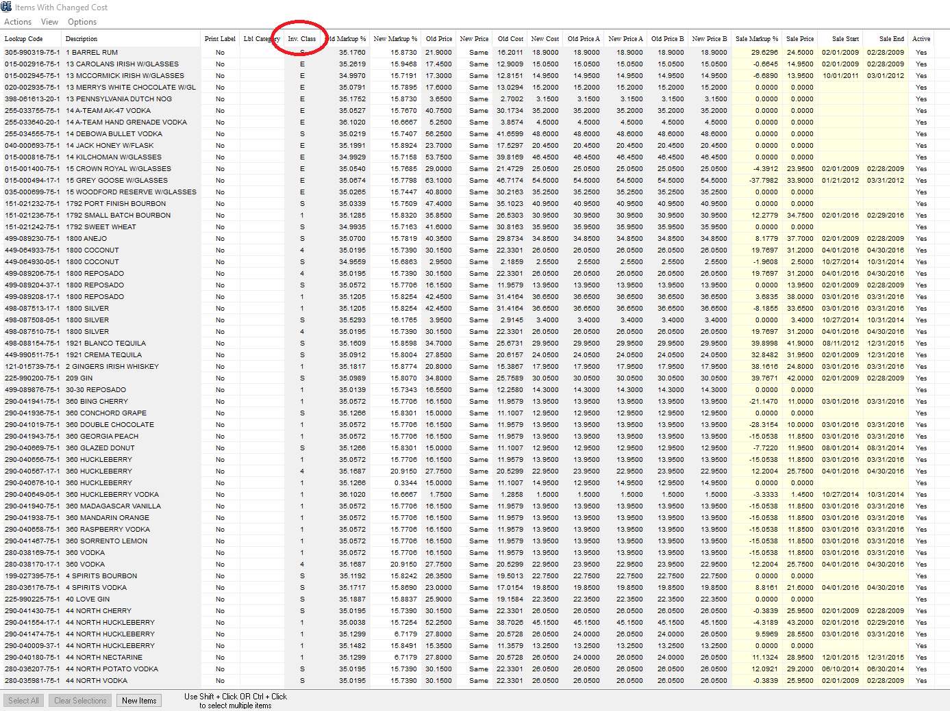

Step 2: Scroll down until you see the top line that has Inv. Class 4 and left click the item so it turns blue.

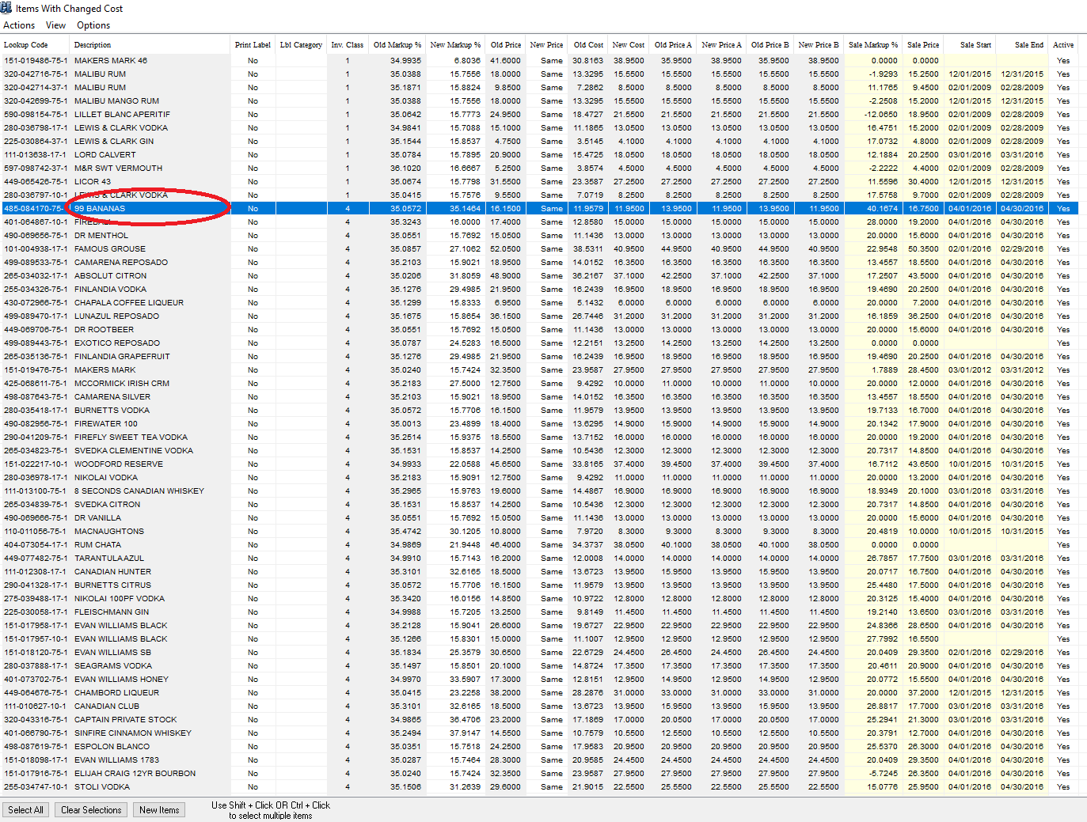

Step 3: Scroll down until you see the bottom line that has Inv Class 4, hold down the shift key on the keyboard and left click the item so all the class 4 items turn blue.
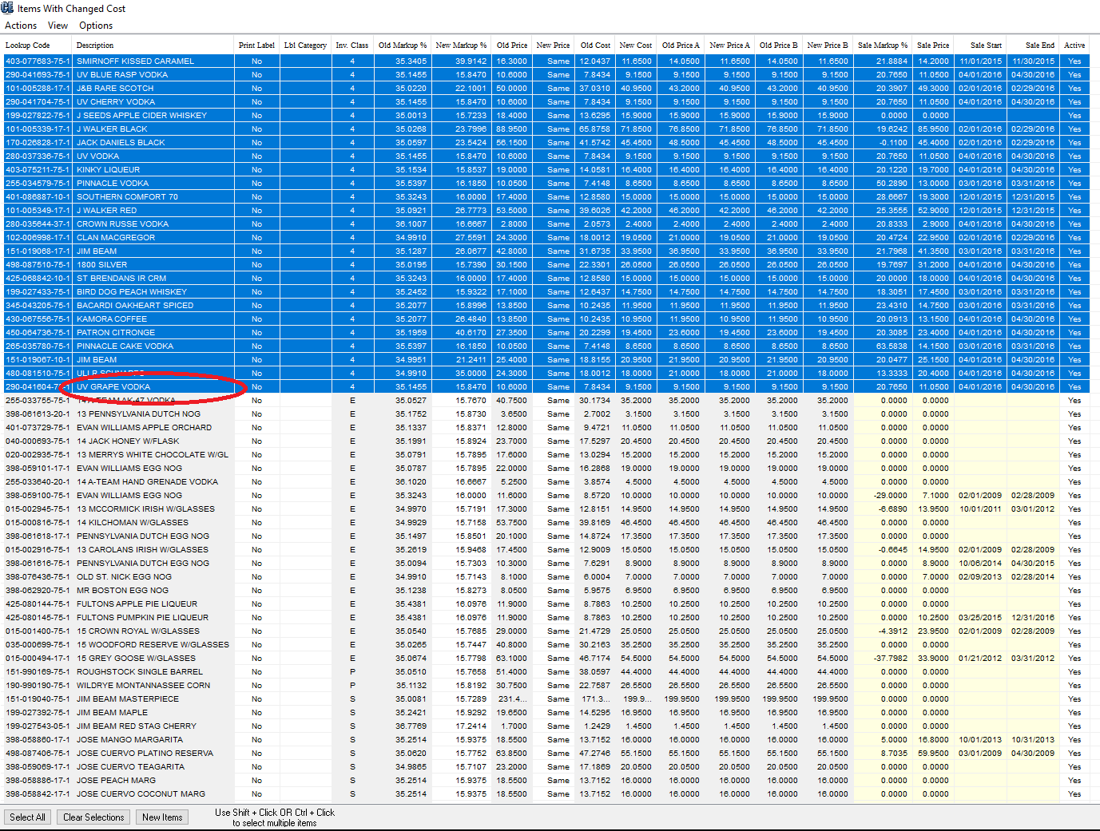

Step 4: Left click Actions at the top left of the page, left click Sale, left click Set Sale Markup For Selected Items. Fill out the Set Markup box with the markup you desire and correct rounding option and left click OK.
Step 5: Left click Actions at the top left of the page, left click Sale, left click Select Sale Start Date For Selected Items. Select the correct Sale Start Date from the calendar that pops up.
Step 6: Left click Actions at the top left of the page, left click Sale, left click Select Sale End Date For Selected Items. Select the correct Sale End Date from the calendar that pops up.
SALE PRICES ARE NOW SET

Step 7: Left click New Markup %, Left Click Sort, Left Click Ascending. This will sort the items by New Markup %.
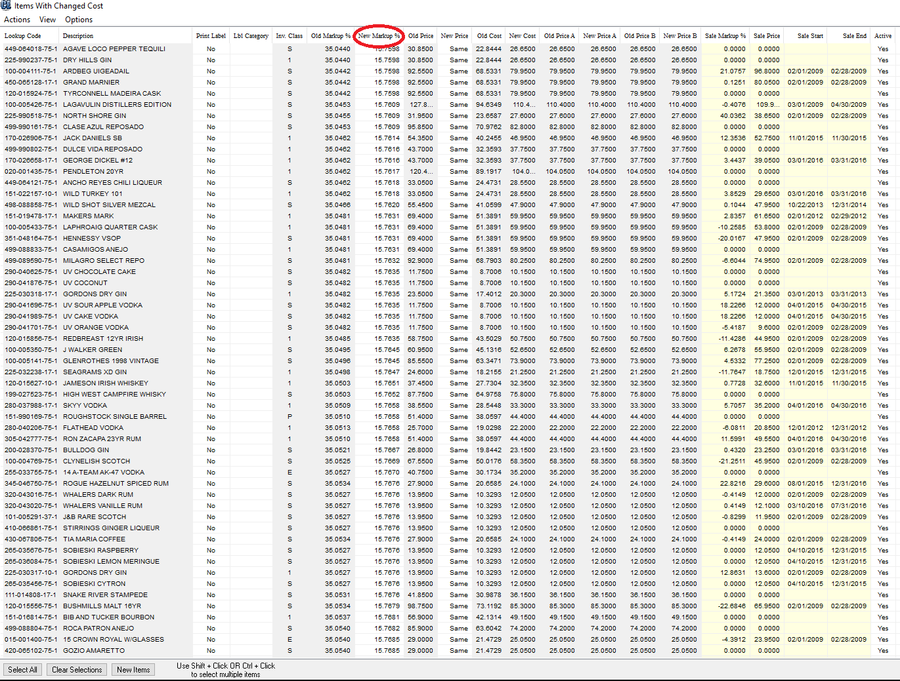

Step 8: Left Click the top item so it turns blue.

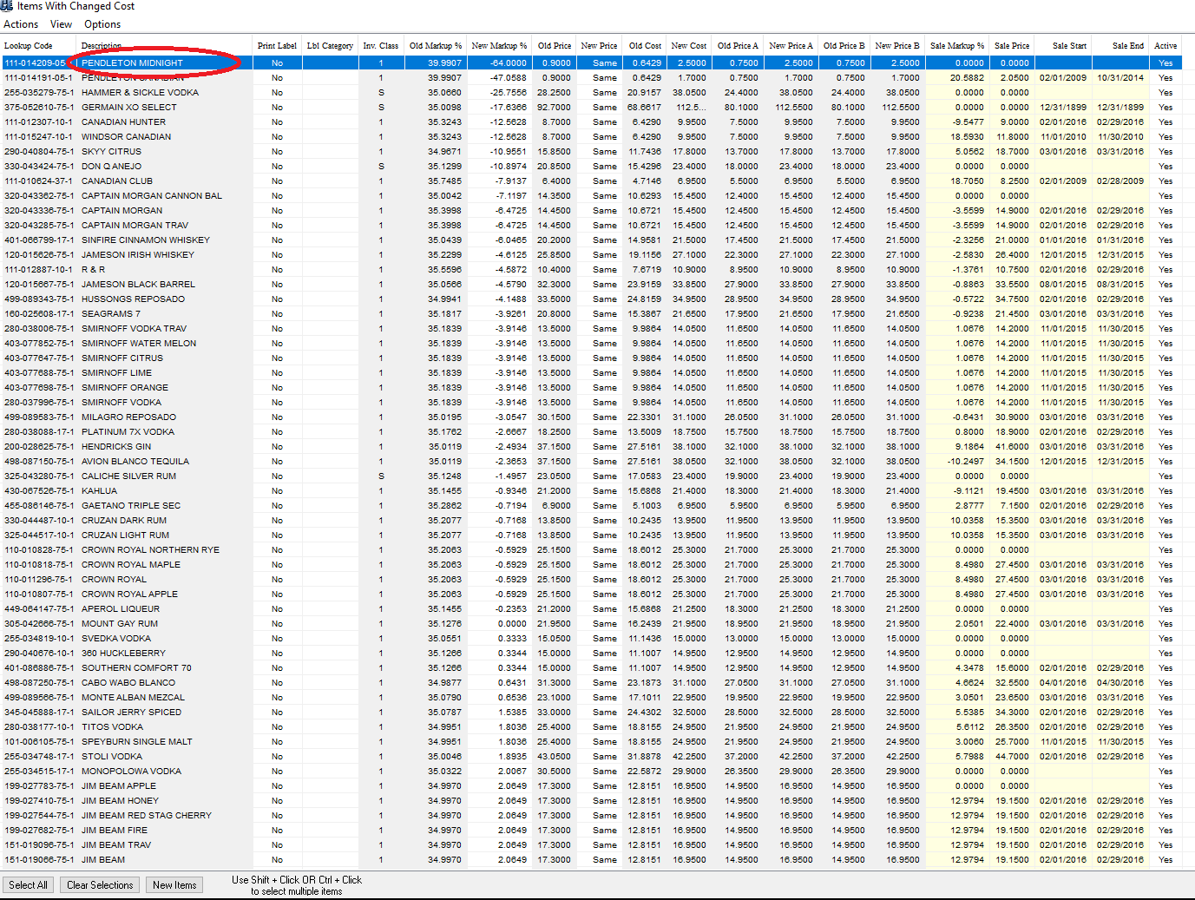

Step 9: Scroll down until you see the bottom line that has a low markup % that you wish to increase, hold down the shift key on the keyboard and left click the item so all the items you wish to increase the shelf price on turn blue.
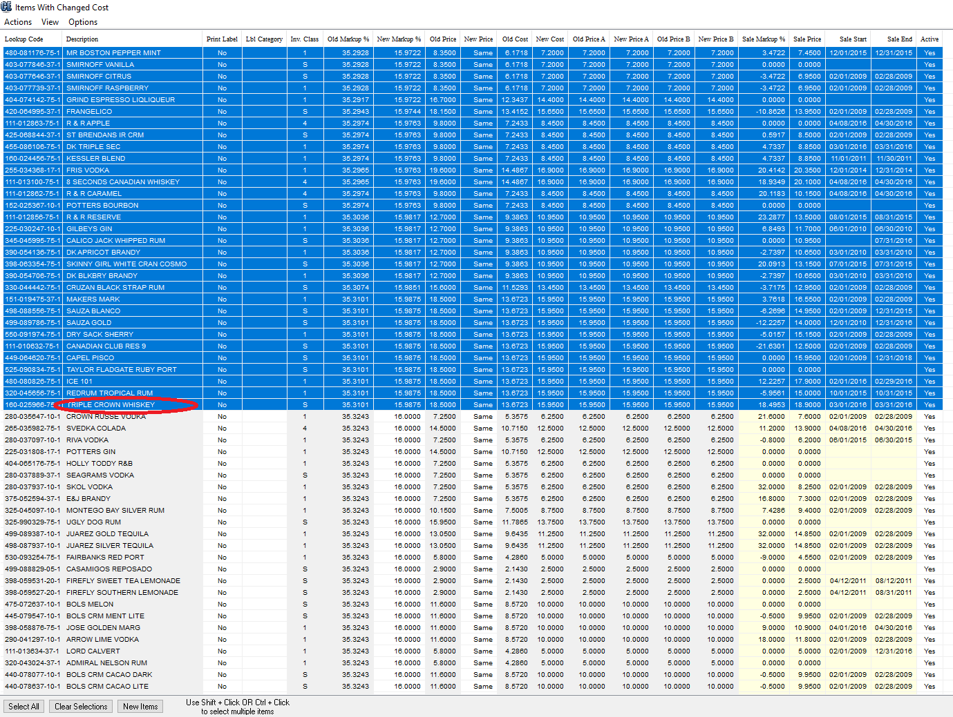

Step 10: Left click Actions at the top left of the page, left click Markup And Price, left click Set Markup For Selected Items. Fill out the Set Markup box with the markup you desire and correct rounding option and left click OK.

SHELF PRICES ATE NOW SET

Step 11: Left click Import Prices at the bottom right corner of the screen. Left click Yes to Continue with update, left click No when it asks you if you want to save before updating.

Step 12: Wait for the changes to be loaded into the system and you should get a message that says “The data update was completed successfully.”
Step 12: Left click Create New Price Labels.
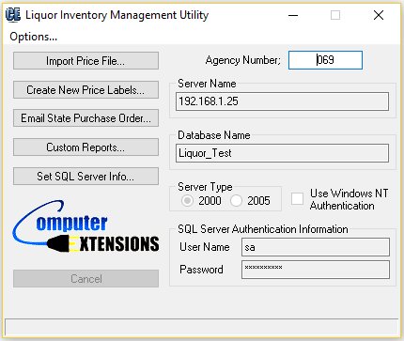

Step 13: Left Click on the batch of labels you would like to print.
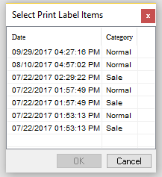

Step 14: Take note of the number that comes up in the message. In this example it is 7.
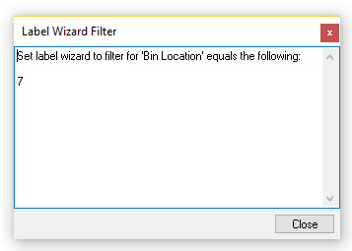
Step 15: Open the RMS Manager and left Click on the Label Wizard at the top of the page (yellow tag icon).
Step 16. Click Next on the Welcome to the Print Label Wizard.
Step 17. Click on the selection that says Print labels for items in the following filter. Then left click the magnifying glass and a filter should come up.
Step 18: Left Click Bin Location in the Field box so it turns blue, then left click the Filter Value box and enter the number from step 14 above. Then left click the add button so Bin Location = (your number) in the filters box. Then left click OK. Then left click Next.
Step 19: This should add all the labels for the batch you want to print to the label selection list. Now you can click Add All and finish printing labels.
Step 20: If you need to print two batches of labels (both regular and sale labels, you can get both batch numbers from step 13.

